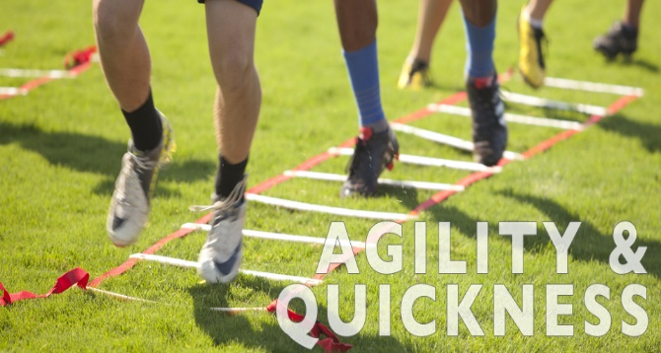
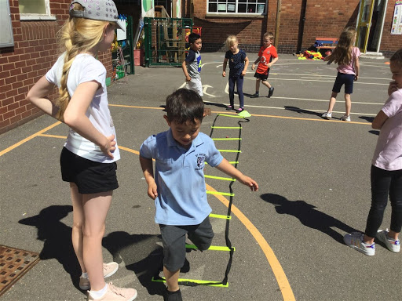
Overall Aim
The aim of HealthLeaders is to introduce and develop leadership skills in Year 5 and 6 children by training them up and getting them to organise activities for other children in the playground around the theme of health and fitness. HealthLeaders is very similar to Playleaders except we use a lot of fun drills around the concept of Speed, Agility and Quickness (SAQ).
Who is it for?
HealthLeaders is predominately aimed at Year 5 and 6 children; however, this programme can also be taught to Year 4.
Curriculum or Extra-Curricular
Pupils can use their leadership skills to teach other pupils during morning, lunch or afternoon breaks. Some schools may decide that this can be part of their change 4 life club offer.
How can HealthLeaders help your school?
- It can be an excellent way of engaging your least active pupils.
- The leaders learn to understand the structure of an active session.
- It is a great way of building confidence for both the participants and the leaders.
- Increases participation rates.
- Breaktimes are a lot more structured and safer games are taking place.
- The Leaders gain a sense of responsibility which for some pupils can be an excellent way of channelling behavioural issues.
- With fun active games taking place the playground then becomes a happy place for children to enjoy their breaktimes.

