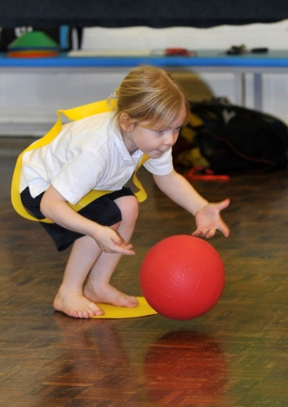**Overall Aim**

Move with Physical Literacy Programme

'Move With’ Physical Literacy Programme has been successfully running in many schools at KS 1 and is now fully embedded into their Scheme of Work.  This resource was developed to provide teachers with a range of ideas and approaches which they can use to ensure that pupils develop fundamental skills and control in order to become competent movers.  
  
Schools have Beginners, Intermediate and Advanced books for both Games and Gymnastics.  Lesson plans are designed to be clear and simple, focusing on the quality of movement to develop agility, balance and coordination.

**Who is it for?**

There are Beginners, Intermediate and Advanced books for both Games and Gymnastics.  Lesson plans are designed to be clear and simple, focusing on the quality of movement to develop agility, balance and coordination; and is primarily aimed at key stage 1

**Curriculum or Extra Curricular**

Physical Literacy can take place in any environment whether it be in curriculum time or during an extracurricular activity.

**How can Move with ‘Physical Literacy’ help your school?**

* Developing physical potential
* Fostering self confidence and self esteem
* Promoting health and well being
* Nurturing effective interpersonal relationships
* Encouraging an active lifestyle
* Challenging individuals to take responsibility for their own well being
* It can enhance and add new ideas to your current Key Stage 1 provision.
* Its fun, dynamic and challenging to all.