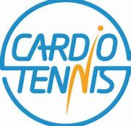
Overall Aim
Cardio Tennis is a high energy fitness activity that combines the best features of the sport of tennis with cardiovascular exercise, delivering the ultimate, full body, energy burning workout.
Who is it for?
Cardio Tennis is fun, sociable fitness class set on either a tennis court or playground and is open to all ages and abilities
Curriculum or Extra-Curricular
Cardio Tennis is a great way to engaging pupils in tennis through a fun session but is also a great way to improve pupil’s fitness and mental wellbeing. Cardio is perfect both in and out of lessons and can be geared to all ages. The after school could be part be part of your school change 4 life club offer.
How can Cardio Tennis help your school?
- It can be an excellent way of engaging your least active pupils.
- It is a great way of building confidence.
- Increases participation rates.
- With fun active games taking place pupils are not only gaining skills but also improving their general fitness levels.
- It is a flexible, informal, non-traditional training opportunity which offers additional motivation for your participants.
- It help the health and mental wellbeing of pupils
- Its fun, dynamic and challenging to all

